AUTHOR'S NOTE
This study guide is a result of generalization of the 15-year experience of teaching the fundamentals of improvisation to the students, which learn the specialized course "Piano".
Among the guides on the practical acquirement of the jazz harmony and improvisation, the most popular in the post-Soviet field are the works of I. Bryl and Yu. Chugunov. These works, though they are of undoubted importance, have, nevertheless, a number of disadvantages, which do not allow the education process to be based on them. The principal of these shortcomings is the modesty, which consists in that the authors treat the improvisation process exclusively as the complication and playing the harmonic vertical with no explanation of the principles of the above playing. Such practice unavoidably results in the exponent's obsession with certain cliché unchanged dependent of the stylistics of the particular creation. In other words, if one adheres to such principles, then the same chord in the different-character plays will produce the same sounding, but in different tempos and tonalities. This creates a direct contradiction for the principle of the exponent's improvisation, which at its core must very sensitively respond to the nuance of the artistic sense. Therefore it is necessary to complement the skills of the work with the harmony by the ability to create the melodic horizontal, which easily obeys the principal line of the development of the musical dramaturgy of the creation, forming the sound coloration corresponding to the imaginative subject of the creation. Only in such conditions the musical creation acquires the solidity of the content and form, which during many centuries was the creative credo of the leading masters of the music art.
The note material suggested by the authors for working out the technological methods draws certain objections. Both Bryl and Chugunov suggest for such exercises the themes that may cause difficulties even for the experienced masters of improvisation art, while in students, who only start to gain possession of improvisation basics, they may provoke the feeling of insuperable difficulties. In addition, if a student on the initial stage even starts to work with the P. Desmond's "Eleven Quarters", C. Parker's "Ornithology" or S. Rollins' "Oleo", the creative process becomes the puzzle – it is necessary to complicate difficult chords, crate improvisations on the theme, which is almost the improvisation itself. Certainly, I don't want to say that learning improvisation is not a complicated process. In contrary, it requires complete commitment. However, on the initial stages, which this guide is devoted to, it is necessary to carry out teaching on the basis of the simple themes of the song-like origin – the jazz songs and not only the jazz ones. The practice shows that the students, having deeply adopted the methods of the complex improvisation (dramaturgy) on the basis of not complex examples, will easily (given their will) transit to more complicated themes and, what is the most important, possessing the method, feel a freedom during their work.
This study guide consists of two parts.
The first part includes the methodological progress in the course "Fundamentals of Improvisation" as the component of the professional training of piano players specified by the relevant syllabuses. Each of three sections of this part deal with the stage-to-stage exposition of the methods of teaching the fundamentals of improvisation by acquiring the harmonic improvisation, the melodic and harmonic improvisation and the melodic improvisation (by the example of the blues technique). The pedagogic experience has shown that working with these aspects of the creative work forms in students the ability to compose individually the plays – variations, adaptations, blues, and ballads, to choose the high-artistic accompaniment and to estimate more professionally the musical phenomena of contemporaneity. The note supplement to the first part presents creations of the students, who not only gained the skills of the exponent's improvisation but also acquired the basic principles of composition and dramaturgy.
The second part of the guide study comprises the author's orchestrations for the piano trio (i.e. the violin, the cello and the piano). The subject of the plays is based on the traditional jazz heritage beginning from the adaptation of spirituals, traditional songs and dancing music and concluding by the author's themes in the "swing" style.
The second part includes two sections. The first section consists of nine plays. Despite the fact that all of them belong to the same musical trend, almost each play has its own individual characteristics. The themes "GO DOWN, MOSES' AND "DOWN THE RIVERSIDE" belong to the "spiritual" genre. They are distinguished by the unconventional combination of the hummable and march melodies. Such songful and dancing character with the religious implication makes a basis for the whole jazz heritage and is the topical core of the improvisation process.
The plays "WHEN THE SAINTS GO MARCHING IN", "SOME OF THESE DAYS", "JA-DA", "CARELESS LOVE", "YES, SIR, THAT'S MY BABY", "I CAN'T GIVE YOU ANYTHING BUT LOVE" belong to the traditional jazz. These traditional jazz themes are much more complicated by their composition as compared to the spirituals. First, they have their author. Second, each play was written for the specific cast of exponents – dixieland, brass band, review. Third, each composer had own creative approach to the process of composition from the genre positions. So, some plays have the blues form, though they differ from it by the melody and harmony. Almost all plays of the traditional block have the song form – AB or AABA, depending on the scope of the melodic material. The theme "AUTUMN LEAVES" belongs to the pop line. All the chamber adaptations are constructed in accordance with the variation principle, and the melodic improvisations are in the parts of all the three instruments.
The second section of the second part comprises six plays, which are completely constructed on the traditional author's themes. It differs from the first section by that the piano part admits an individual creative approach to the execution. In this case the piano part of the first section plays is a sample for the decoding of the digital system of recording of the harmony.

Approved by the Ministry of Culture and Tourism of Ukraine for the application in the education and training process at the I–II accreditation degree higher cultural and art education institutions – letter No. 1011/3/13-07 dated 31.07.2007.

This study guide is a practical guidance for acquiring the fundamentals of improvisation and includes the analysis of the constructive components of the creative process: forming, harmony, melodics. It may be used not only by the piano players, but also by the students of other instrumental units, vocal units, as well as by the theorists with the aim to develop the creative skills.

Section 1
HARMONIC IMPROVISATION (BENEFICATION)
Harmonic improvisation means rather not the structural approach to the harmony but the qualitative one – by the phonism. It requires from the student the ability to construct the connection between the vivid content and constructive embodiment of the chord structure.
Before we turn to the harmonic variation, let us analyze the themes in accordance with the following plan:
- The form of the theme.
- Cadence zones in the theme.
- Deviation (as a rule, in the tonality of the first degree of affinity).
- Construction of the melody dramaturgy.
Theme "The Forest Raised a Christmas Tree"
Example 6
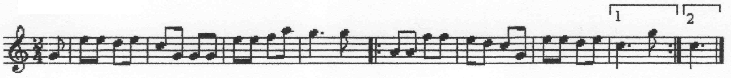
The form of this song is a period comprising two sentences. The first sentence ends with not finished cadence (i.e. not at the tonic, but at the dominant with respect to the subdominant tonality), the second sentence is the accomplished cadence, primary tonality fixation. Thus, we found that:
- The form of the theme is a period comprising two sentences with the repeated second sentence.
- There are two cadence zones: that in the end of the first quadruple measure and that in the end of the whole construction (example 6a).
Example 6a
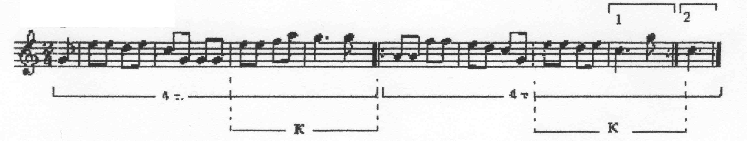
Before we turn to the item 3 "Deviation", we will clarify first that deviation in our case is a temporary digression from the main tonality of the play to the other tonality sphere, the stable basis of which is defined by a certain diatonic tone.
To find the deviation we need the harmonic analysis of the theme (example 6b):
Example 6b
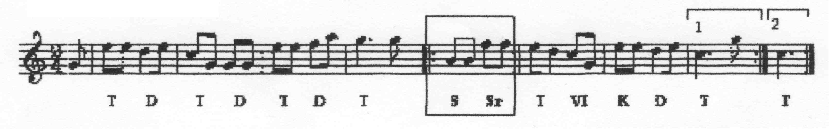
It is seen that the subdominant fraction dominates in the fifth measure. Moreover, starting from the fifth measure the relevant part of the whole musical construction begins. Beginning of the play – the pickup measure – enhanced the domination of the tonic function and, thus, the tonic was the overwhelming element of the harmony of the interrogatory part of the play. The second part withstands it from the first measure by dominating plagal function (i.e. the subdominant). In addition, the subdominant sphere is prepared by the ending of the first (interrogatory) part in a form of the unfinished cadence. After the dwell in the forth measure at the fifth tone, the melody, thus, weakens the tonic functionality, forcing the hearing to rethink the tonic from the fourth position of the transient, not principal, chord. In this case the fourth measure tonic becomes dominant with respect to the fifth measure subdominant. Thus, the imperfect cadence in the first sentence is harmonically verified (example 7):
Example 7
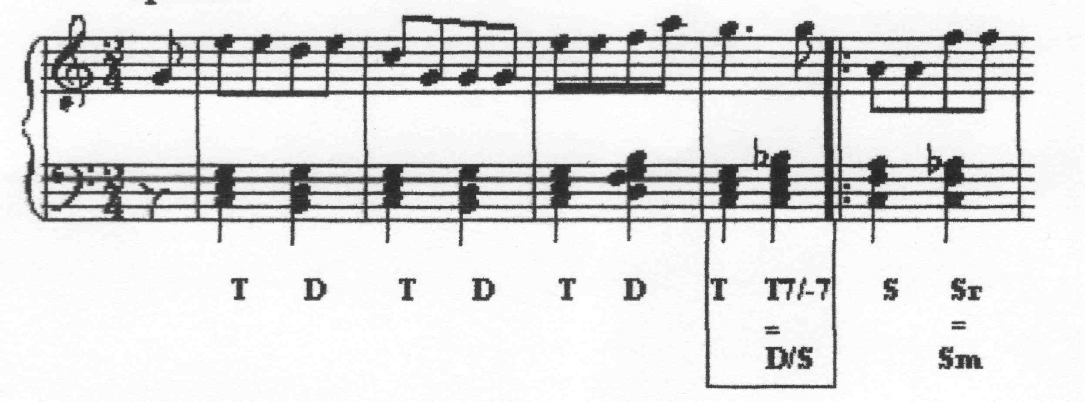
Thus, we get acquainted with the deviation at the transition from the fourth measure to the fifth one, from the tonic function to the subdominant one. The similar deviation occurred due to the dominant seventh chord. It contains the tritone interval in its structure, which differs by its instability and is inclined to the untying. Thus, the acoustic stress and instability of the small major seventh chord requires logical untying to the stable sphere. In this case we deal with a certain variation of the tonic function (due to the reduction of the chord's seventh). During transformation into the dominant seventh chord, it is untied into the subdominant function. Hence, any deviation includes at least a small major seventh chord (D7). However, this small major seventh chord (D7) is almost always present in the cadence idiom as the brightest one, which requires untying into the expected tonic. Therefore its appearance is "delayed" due to the plagal chords (S-function) . However, since the deviation is a temporary withdrawal to the secondary tonality, then "rarefaction" of the small major seventh chord will take place by the characteristic chord of the S-function, i.e. by the II degree chord (example 8):
Example 8
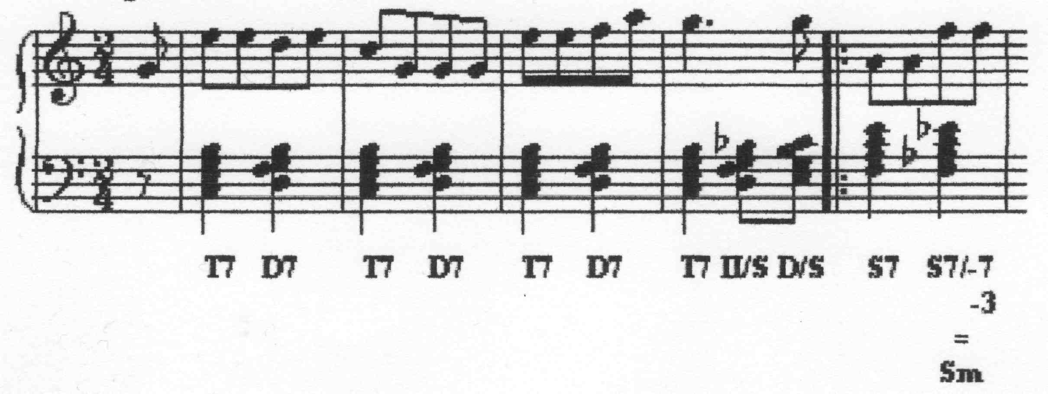
Thus, deviation takes place in accordance with the formula: II – D. Example:
Example 9
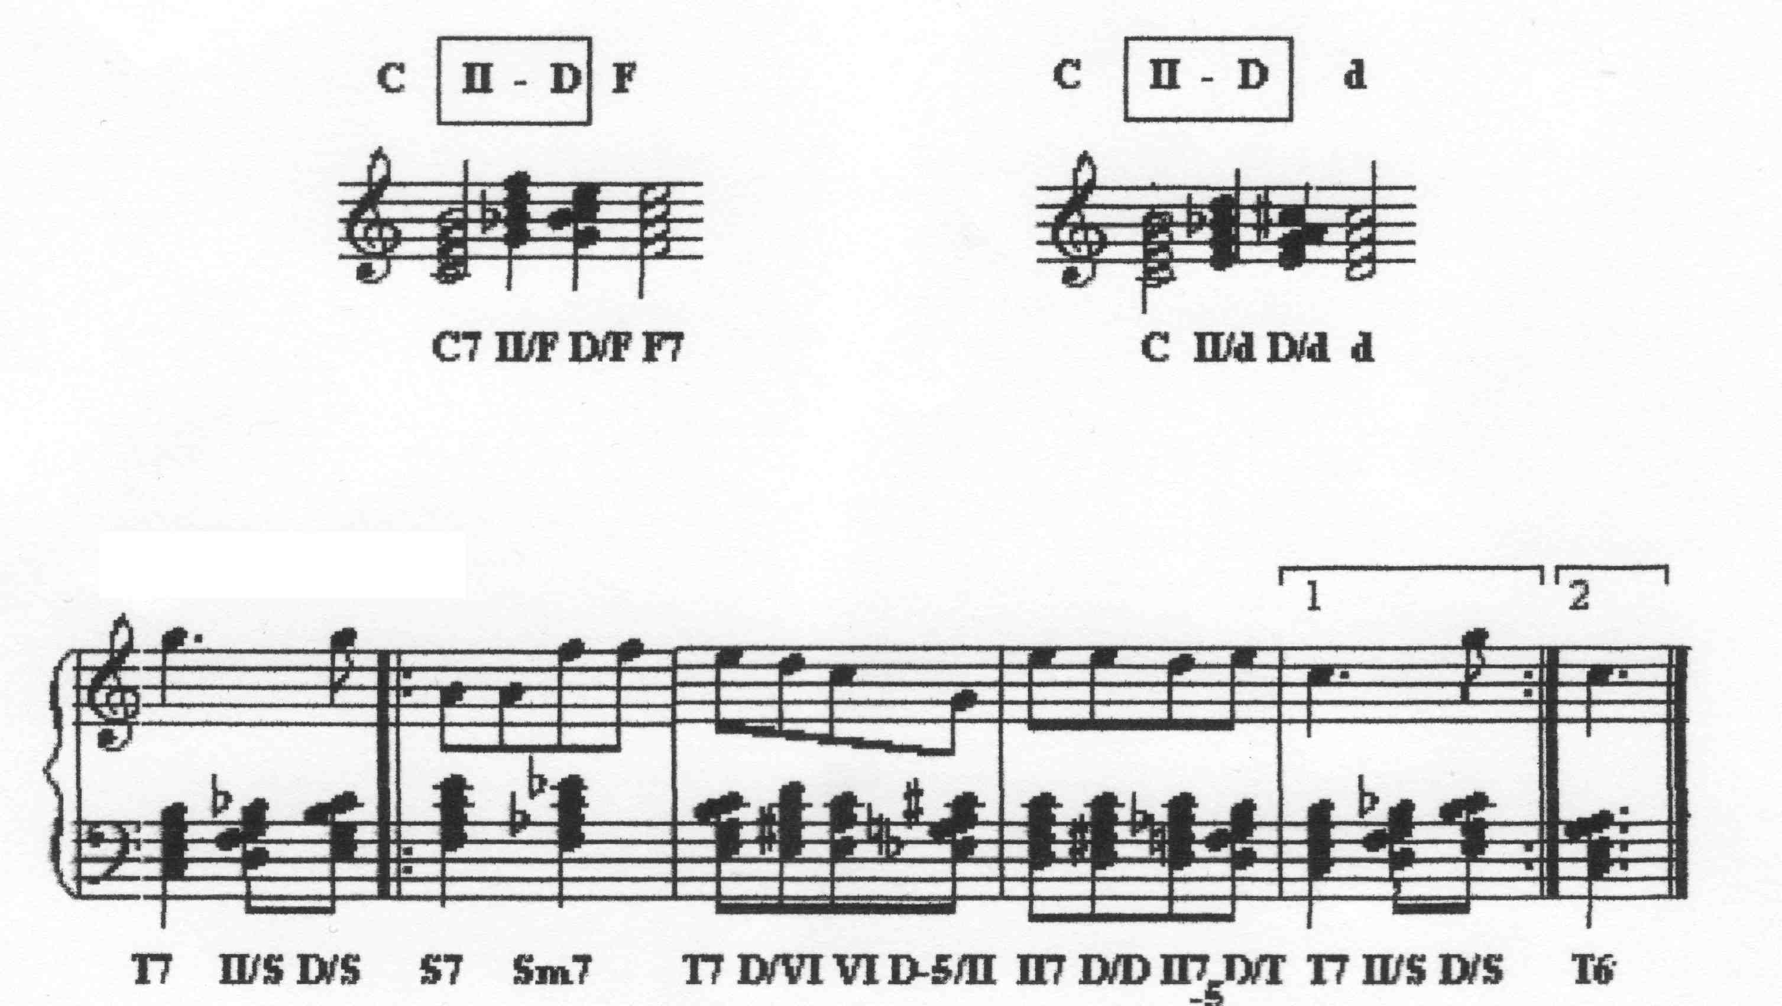
Using this example (example 9), one can see how many potential deviations are included in the second sentence of the song "The Forest Raised a Christmas Tree":
T II/S D/S || : S7 Sm | T D/VI VI D/II | II D/D II₋₅ D/T |T₆
T D/VI VI  D/II  VI II | CADENCE REGION:  T S D T  S K_{6/4} D T  II D/D= II_{7/-5} T  II_{7/+3} D/T

The seventh measure demonstrates clearly not only the D7 "rarefaction", but also its "retraction" as the last stressed vertex before untying into the tonic. The metamorphosis of the subdominant function chord – the II degree chord – takes place. Just this chord is the most desirable in conjunction with D7 for the following reasons:
- it is located one tone from the tonic;
- the minor tritone makes its basis;
- the prime II7 is the basis of D43;
- the fifth II7 falls on the VI degree, which take part in the harmonic major creation;
- the alteration of the IV and the VI degrees, i.e. the thirds and the fifths II7, accentuates the tension in D7, after which untying into the expected tonic looks logic.
Thus, the formula II – D – fixes the positions of the most used idiom at the deviations. In addition, conjunction II – D in the context of harmonic sequence (in this case – the harmony of the song "The Forest Raised a Christmas Tree") stimulates a considerable benefication of the harmonic series. Not only new harmony appears, but also new harmonic structures occur – instead of the common chords the seventh cords are used that appeared as a result of "building out" of one more third to the tritones. Now we can hear the theme in the new harmonic interpretation (example 10):
Example 10
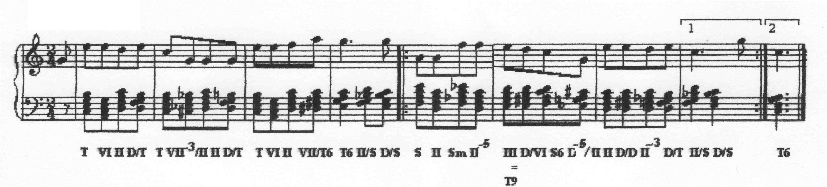

Yu. Chugunov. Harmony in Jazz. Study guide for piano – M.: Sov. Kompozitor, 1985; I. Bryl. Practical Course of Jazz Improvisation for Piano. Study guide – M.: Sov. Kompozitor, 1985.
T→III; S→II; D→VII. The matrix of the chord location over the functions: T – – D – T. Therefore, any functional chords are possible after T and before T. Only the chords of the function T and just S are possible before S. After S – the functions S, as well as D and T are possible. The chords of the functions T and S are possible before D. After D – D is enhanced by the chord of the VII degree and T.
Yu. Chugunov in his work "Harmony in Jazz" (p. 10) suggests relating the VI degree chord both to the T- and S-functions. In our opinion, this is an error, because such approach to the most exact part of music, the harmony, gives no clear pattern of the functional relationships. On the initial stage of acquiring the harmonic improvisation this makes some incomprehension in student concerning the relatively clear chord sequences (see note 4).

